**Creating ASG:**

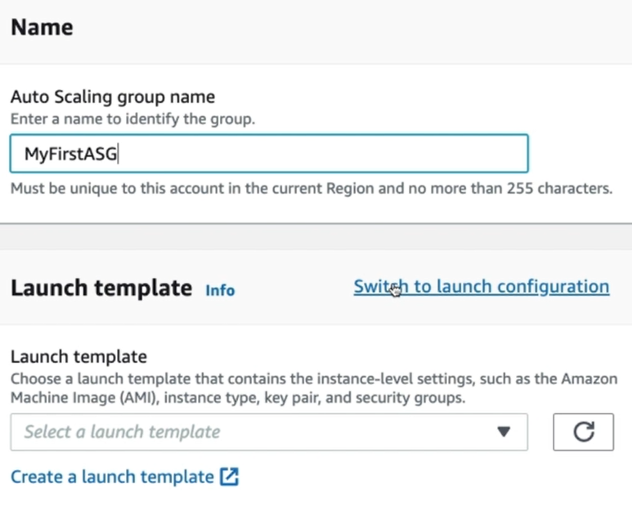

* While creating ASG, give a name to scaling group, then switch to launch configuration or create a launch template as below
* Launch template describes how the EC2 instances to be created.

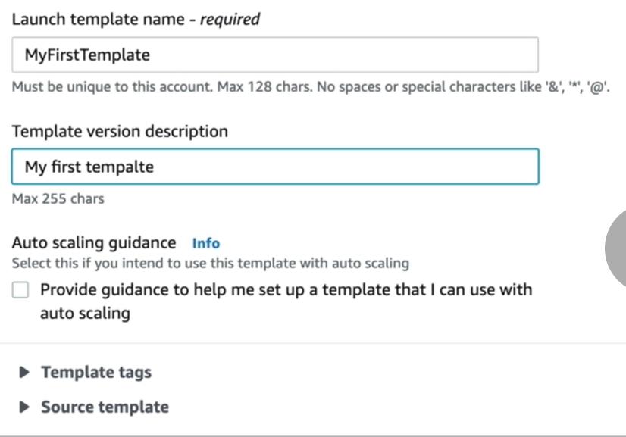

* Give a name and description to the templates. We can add tags if need.

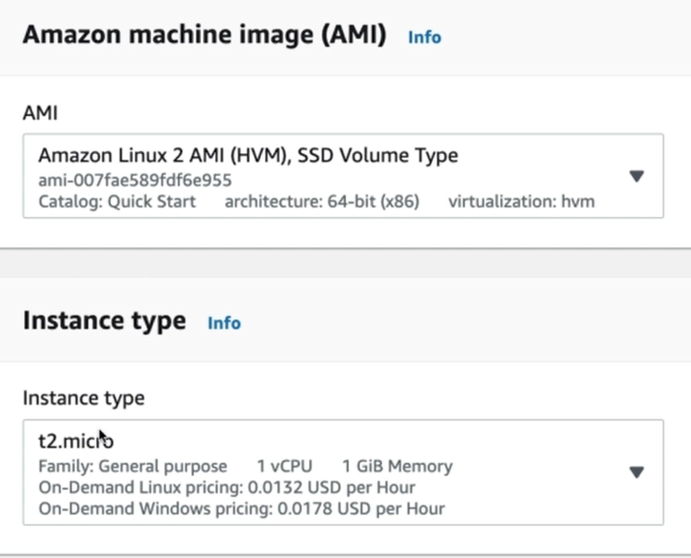

* Next we need to select the AMI an instance type as above.

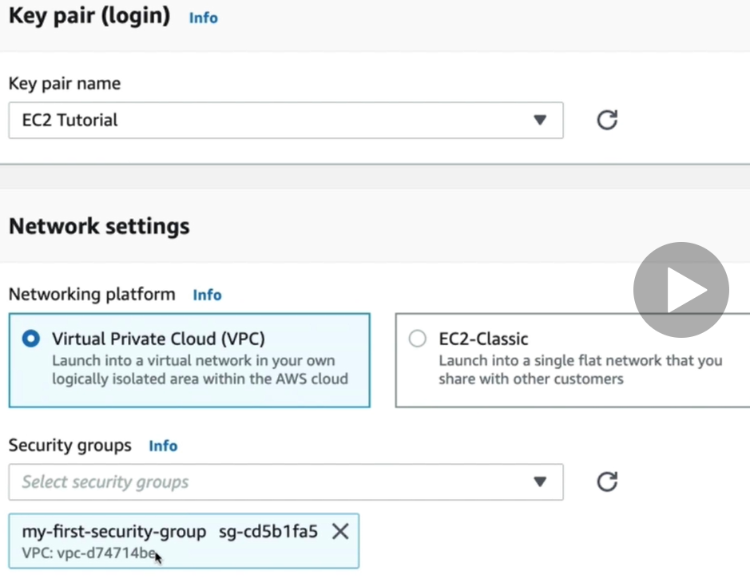

* Select the keypair, and the network type as VPC and the security group as above.
* Then volumes, tags and network interfaces if we want to.

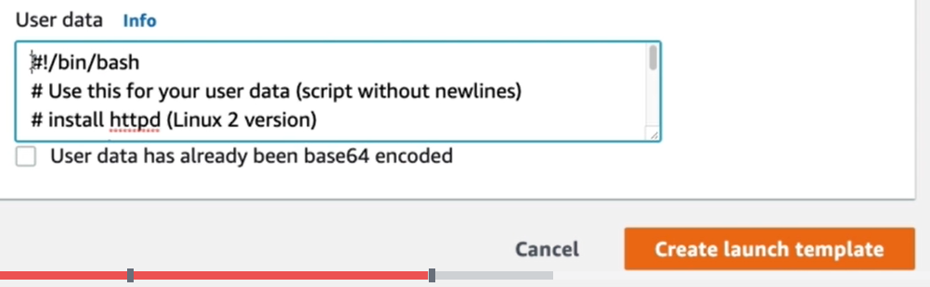

* Then in advance settings, we can add the script which we want to get executed at the time of server start-up.
* Once the template is configured, we need to give the instance type in next step as below.

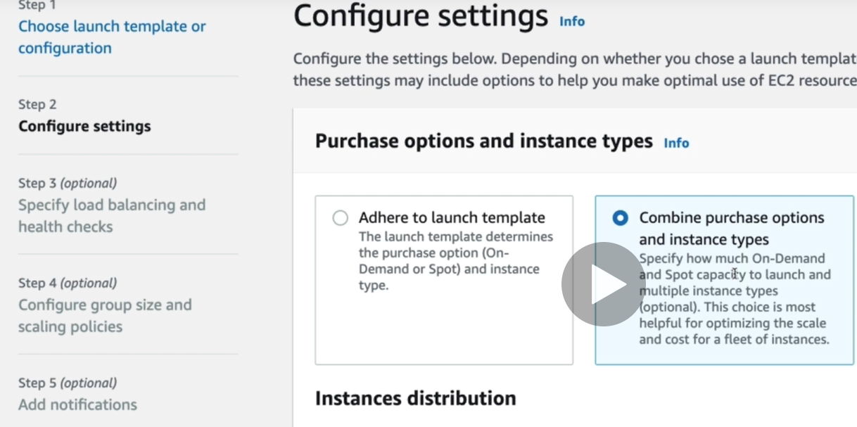

* Once we select the option **“adhere to launch template”.** Then we need to select VPC and subnets under that as below.

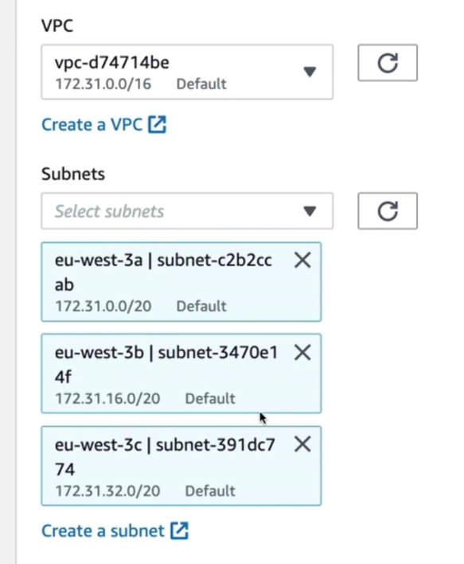

* We can add the subnets where we want to launch the auto scaling. It is always good to have minimum two zones

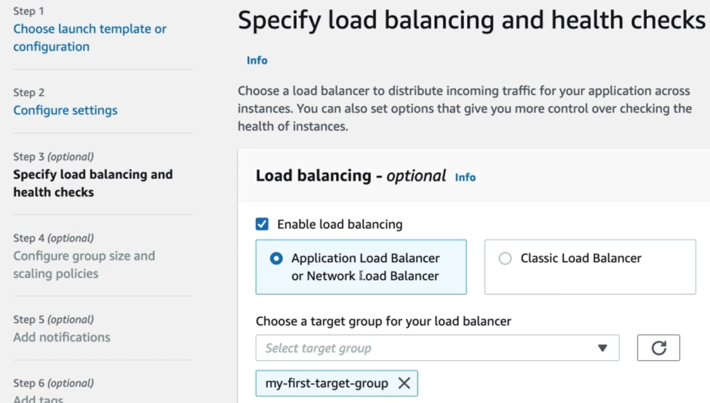

* In next step, we can enable the load balancer and choose target group as above. So, if ASG adds any server, it will be automatically added to the target group.
* Autoscaling groups can be integrated with load balancing. So, whenever a new instance added to the group will automatically added to the load balancer

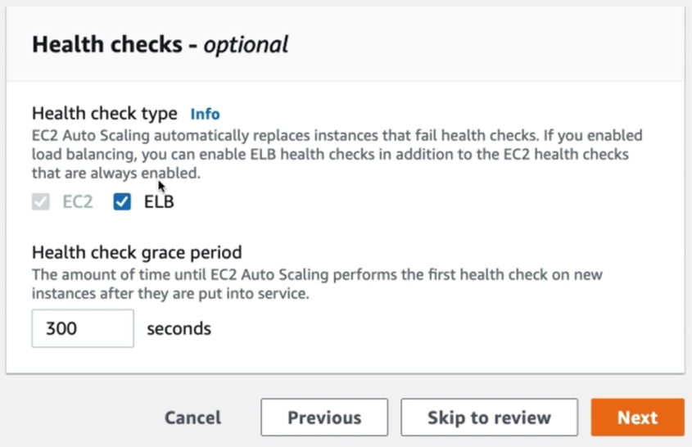

* Under that, we can select the health checks directly to the EC2 to perform on or we can select ELB. So that if health check fails in ELB, then ASG will terminate that instance and recreates it.

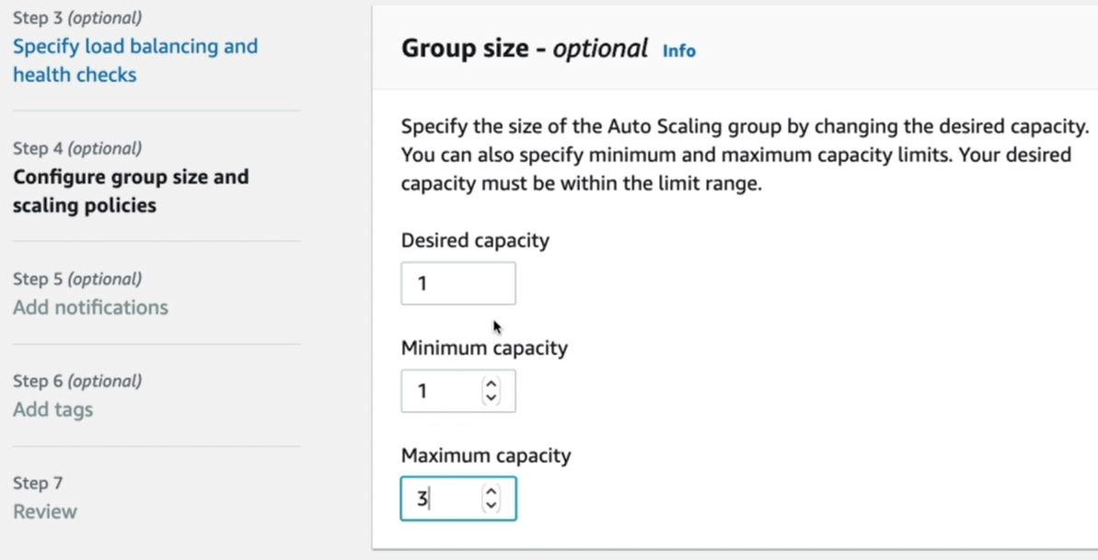

* We can set the group size in next step as above.

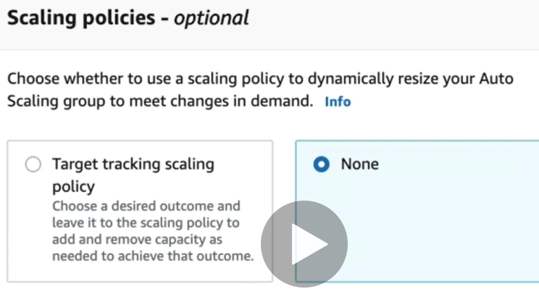

* We can add scaling policies as well.

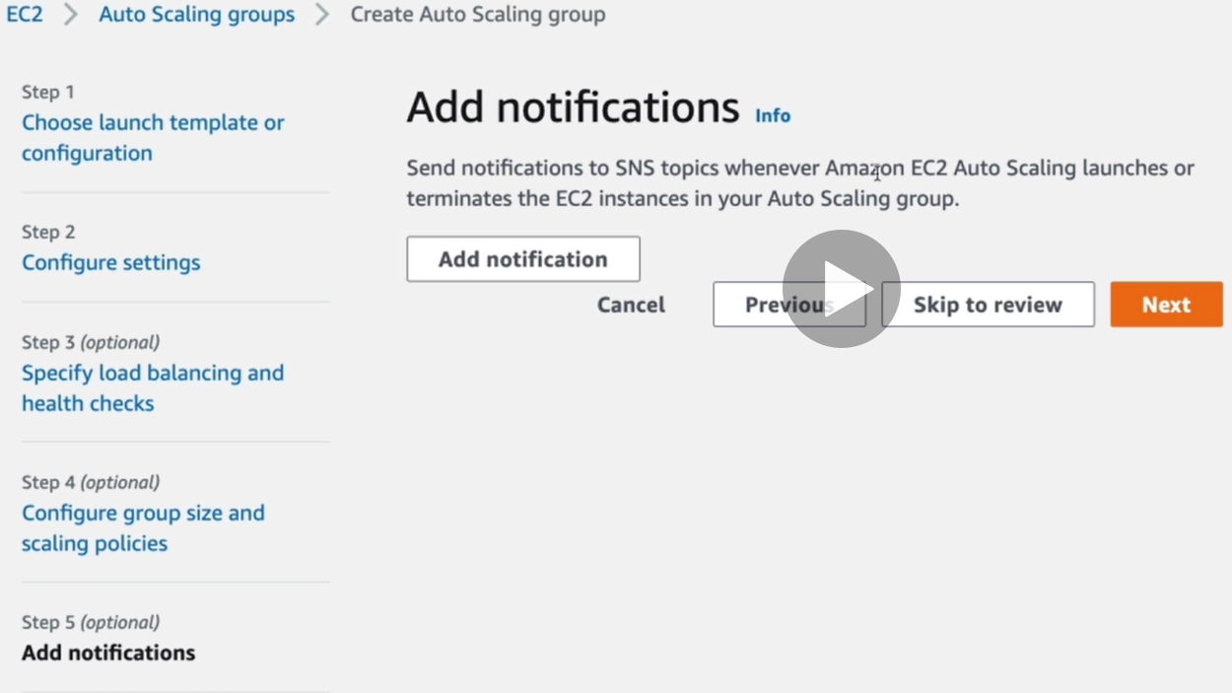

* We can add notifications as well.
* Then we can add tags, review the configurations and create ASG.
* Now, we can see the instance creates under ASG as we gave desired state as 1. The same we can find in LB target group as well.

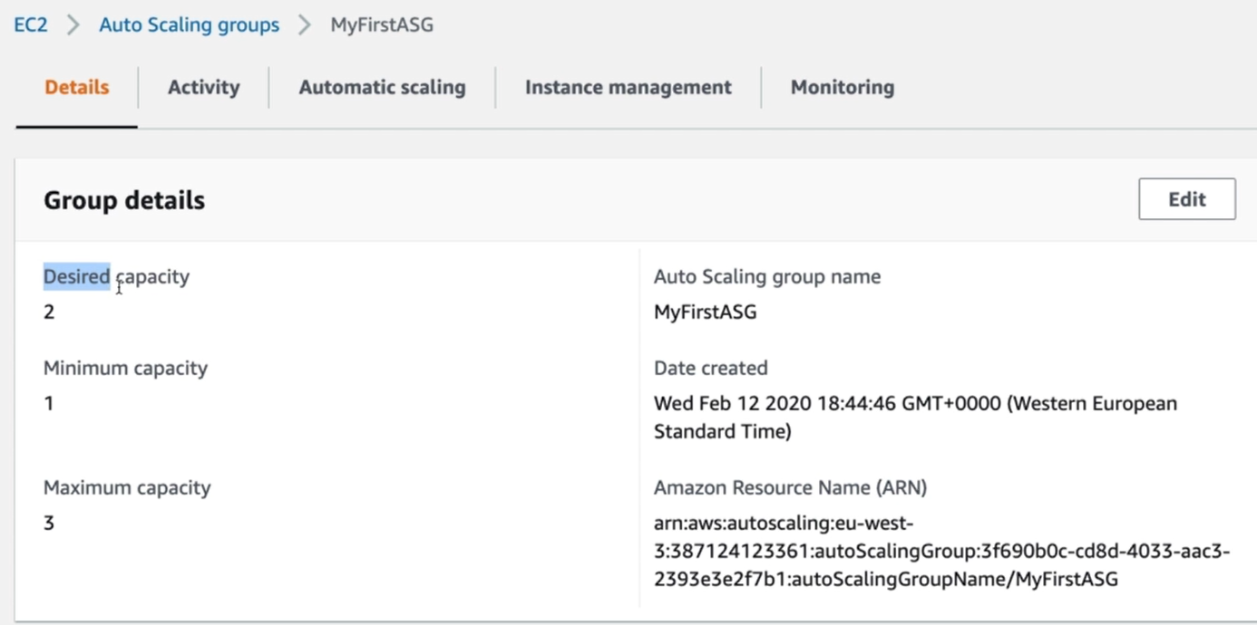

* If we increase the desired, it will automatically launces new instance to keep the desired state always.

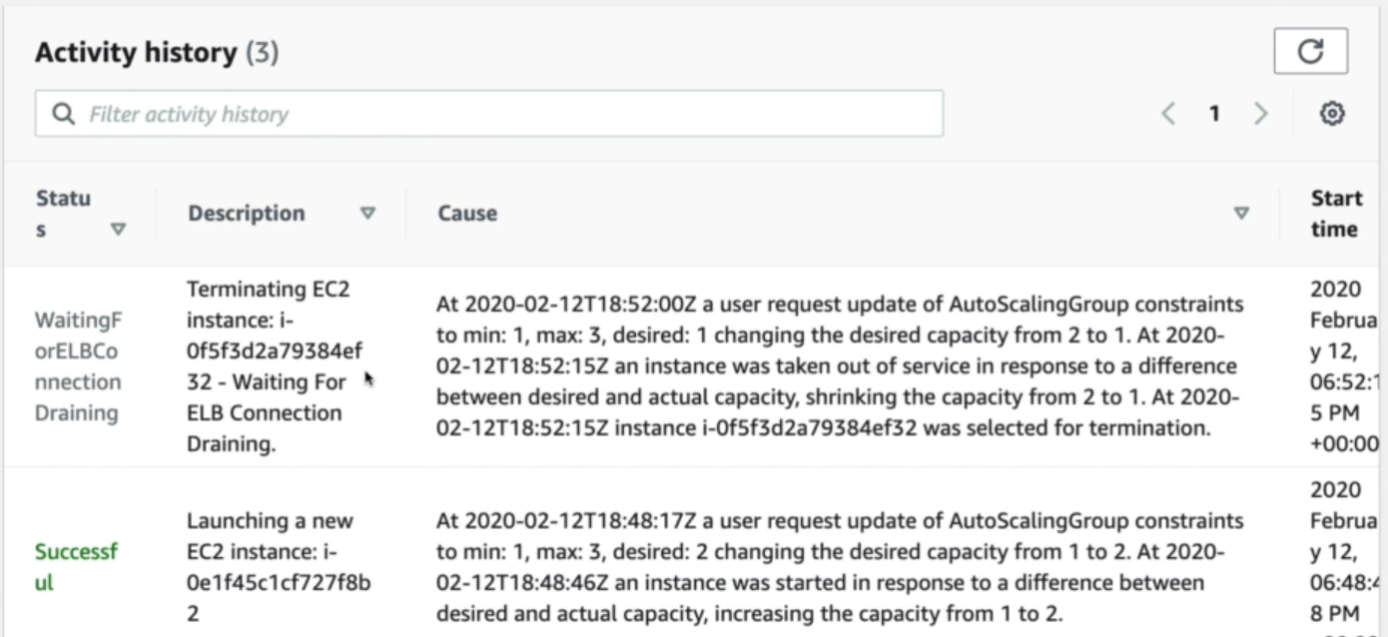

* Now, if we decrease the desired state to 1. ASG will terminate one instance we can see the in-activity history.